St Pius X Catholic Parish Heidelberg West acknowledges the Wurundjeri people.

Fr Wayne Edwards: St Pius X Presbytery 419 Waterdale Rd Heidelberg West 3081

Tel: 9457 5794 Fax: 9457 1036 Email: heidelbergwest@cam.org.au

Exodus Community: 273 Liberty Parade Heidelberg West Tel: 9457 7593

School Principal: Barbara Gomez Tel: 9457 3776 Email: bgomez@spxhw.catholic.edu.au

_________________________________________________________________________________________________

MASS TIMES

Sundays Saturday Vigil 7pm Sunday 9am & 11.00am

Exodus Community, 12 Noon in the shed at 273 Liberty Pde, Heidelberg West

Weekdays 9am Tuesday, Wednesday, Thursday, Friday, Saturday

CONFESSIONS & ROSARY After 9am Mass on Saturday mornings

CHURCH OPEN FOR PRAYER 8.30am – 4pm on school days only

PARISH WEBSITE - pol.org.au/heidelbergwest

St Pius X Catholic Church Heidelberg West actively works to listen to, empower and protect children, and has zero tolerance for child abuse and neglect.

PLEASE LOOK AFTER YOUR CHILDREN WHILE MASS IS IN PROGRESS
SAINTS/FEAST DAYS FOR THE WEEK
- Monday 11 – St Benedict
- Friday 15 – St Bonaventure

Reflection: “Jesus said to him, ‘Go and do likewise.’” Luke 10:37
This was Jesus’ command at the end of the Good Samaritan story. Did you know that the Samaritans and Jews despised each other? The moral of the story is to love our neighbor. That means loving someone you may not know, or someone that looks different than you, or someone that has different beliefs than you, or someone that you don’t like. All without expecting anything in return.

Next Sunday: July 17th
 | Reader | Special Ministers
Saturday 7:00pm | Phoebe Davies
Sunday 9:00am | Julie Gill
Sunday 11:00am | Felicity Paolucci
NEXT SUNDAY’S READING – SIXTEENTH SUNDAY ORDINARY TIME
Gen 18: 1-10; Ps 14: 2-5; Col 1: 24-28

THANKS GIVING ENVELOPES – AVAILABLE IN FOYER
2022-2023 Thanksgiving envelopes are available for collection in the church foyer.
PLEASE DISCARD ANY UNUSED ENVELOPES FROM THE PAST YEAR. I urge those who are not part of our thanksgiving program to consider regularly contributing to the upkeep and future needs and projects of St Pius X through financial stewardship and commitment.

CHAIRPERSON NOMINATIONS
The St Pius X Parish Pastoral Council is taking nominations for chairperson and members. Please contact Fr Wayne or Junia 9457 5794 with any nominations.

STELLA MARIS OPEN DAY
Stella Maris Melbourne invites you to an OPEN DAY
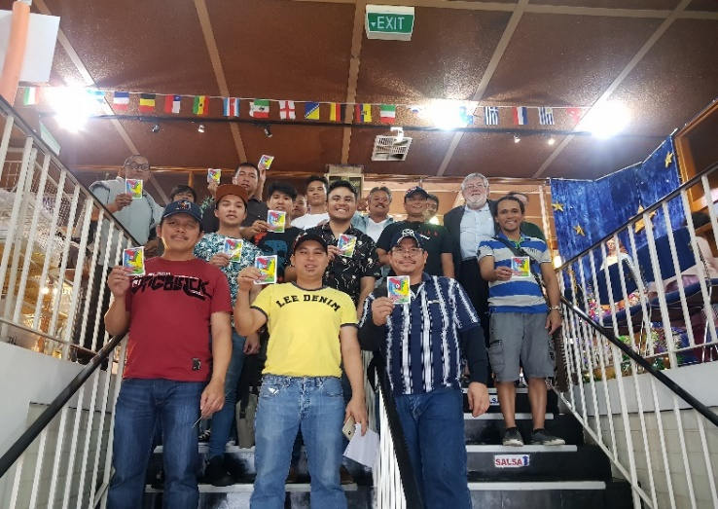
On SUNDAY 10TH JULY, BETWEEN 2PM AND 5PM 600 Little Collins Street, Melbourne
Did you know the Port of Melbourne is the largest container & cargo port in Australasia? Do you ever wonder about the crew on large vessels transporting our goods? Seafarers needed assistance during the pandemic as they were confined to their ships!
Stella Maris is a missionary work of the Church which looks after seafarers
Come and see our Centre and speak with volunteers about the work
FREE BUS TOURS TO THE PORT OF MELBOURNE
The tours will be followed by afternoon tea. We look forward to welcoming you!

ST VINCENT DE PAUL WINTER APPEAL
Inviting parishioners to donate non-perishable food items over the coming weeks. Your donations will be distributed to needy families by the local St Vincent De Paul Society conference. Winter woolies will also be accepted scarves, socks, gloves, jumpers, blankets. Please place items in basket at foot of sanctuary; the basket will remain there throughout winter.

SENIORS GET TOGETHER - JULY
Please join our seniors group on Wednesday July 13th for morning tea at Beasley’s Nursery & Tea House in Warrandyte. The bus will be leaving the St Pius X Carpark at 10.00am. All welcome!
(If you require transport to St Pius X please contact Junia 9457 5794)
https://beasleysteahouse.com.au

Prayers for the Sick; David Tickner, Pauline Curlis, Bill Barnes
For the Recently Departed: Joyce O’Donnell
Anniversary of Death: Gizella Lugosi

